Question Id: 515137
Q 10: Q 10: A 28-year-old patient has just completed treatment for scabies with topical permethrin. To minimize the risk of reinfection and prevent transmission to family members, which of the following measures is most appropriate? (Question Id: 515137)
- Wash clothes and bedding in hot water
- Daily bathing only
- Sun exposure of skin
- Use antifungal powder
- Avoid oily foods
ANSWER: A

Keywords in the Stem to identify correct option
- “Completed treatment for scabies”
➝ Indicates post-treatment preventive advice is being tested, not drug choice or diagnosis.
- “Prevent reinfection and transmission to family members”
➝ Points toward environmental decontamination and control of fomites, not personal hygiene or diet.

Explanation

(Option A) Wash clothes and bedding in hot water:
- Scabies mites and eggs can survive on clothing, bedding, and towels for 2–3 days.
- Washing clothes, bedding, and towels in hot water (>50°C/122°F) and drying in a hot dryer kills mites and eggs, preventing reinfection.
- For items that cannot be washed, sealing them in a plastic bag for at least 72 hours is a recommended alternative.
- This measure is crucial in breaking the life cycle of the mite and preventing family or community spread.

(Option B) Daily bathing only:
- While maintaining personal hygiene is important, bathing alone does not eliminate mites on clothing, bedding, or fomites, so it’s insufficient to prevent reinfection.
(Option C) Sun exposure of skin:
- Scabies mites live in the stratum corneum and are not affected by sunlight exposure. This does not prevent reinfection or transmission.
(Option D) Use antifungal powder:
- Scabies is caused by a mite (Sarcoptes scabiei), not a fungus. Antifungal powders have no effect on mites.
(Option E) Avoid oily foods:
- Diet, including oil intake, has no influence on scabies infestation or reinfection.

Key Concept
Scabies reinfection is most effectively prevented by decontaminating clothing, bedding, and towels through hot washing/drying, since the mites can survive briefly outside the human host. Personal hygiene alone is insufficient.

Exam Pearl
When a stem emphasizes post-treatment scabies + family transmission, always think washing clothes and bedding in hot water to break the mite life cycle.

Subject: Medicine (Internal)
System: Dermatology (Integumentary system) – Infestations & Infections – Scabies - Post-Treatment & Public Health
Topic: Scabies – Prevention and Post-Treatment Management

- Competency Domain: Management
- Cognitive Level: Application
- Clinical Skill: Guideline-based action
- Difficulty Level: Easy

Scabies – Prevention and Post-Treatment Management
Aspect | Details / Features | Key Points / Notes
Patient Measures | • Complete prescribed topical treatment (permethrin, ivermectin)  • Bathe regularly  • Avoid scratching lesions | • Ensures mite eradication  • Reduces secondary bacterial infection  • Relieves itching
Environmental  Measures | • Wash clothes, bedding, towels in hot water >50°C  • Dry in hot dryer or sunlight  • Clean or vacuum furniture, carpets, mattresses | • Kills mites and eggs  • Prevents reinfection  • Reduces household transmission
Contacts /  Family Measures | • Treat close contacts simultaneously  • Advise hygiene measures (shared towels, clothing)  • Monitor for symptoms | • Breaks the transmission cycle  • Prevents outbreaks  • Early detection reduces spread

Differential Diagnosis
Scabies
Condition | Key Features /  Presentation | Distinguishing Points  from Scabies
Eczema /  Atopic Dermatitis | • Intense itching  • Erythematous, dry, scaly patches  • Chronic relapsing course  • Often flexural distribution | • Usually symmetrical  • No burrows  • Family members not affected
Contact Dermatitis | • Pruritus  • Redness, vesicles, oozing  • Localized to contact area | • History of allergen exposure  • Confined to exposed skin  • Rapid resolution after allergen removal
Pediculosis  (Lice Infestation) | • Severe itching  • Nits or lice visible on hair shafts  • Usually scalp involvement | • Mainly hair-bearing areas  • No burrows  • Adult body lice rare on trunk
Psoriasis | • Erythematous plaques with silvery scales  • Often extensor surfaces  • Chronic and relapsing | • No burrows  • Minimal nocturnal pruritus  • Family history may be positive
Fungal Infections  (Tinea corporis) | • Annular lesions with central clearing  • Scaling  • Sometimes pruritic | • KOH exam positive for hyphae  • Lesions expand centrifugally  • Not typically widespread or burrowed
Drug Eruption /  Allergic Reaction | • Widespread pruritus  • Erythematous maculopapular rash  • Temporal relation to drug exposure | • Rapid onset after drug intake  • No burrows  • Resolves after discontinuing drug
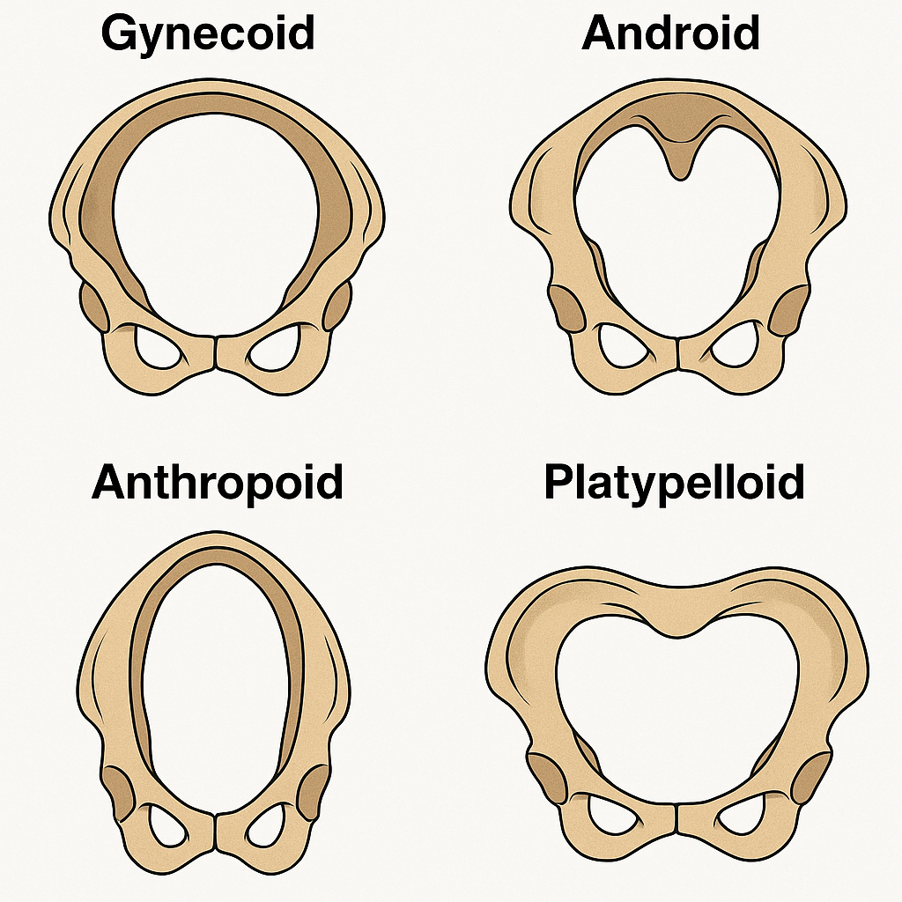

Notes
- Burrows, nocturnal pruritus, family involvement are classic pointers to scabies.
- These features help distinguish scabies from mimickers.

